SECTION 8.4:
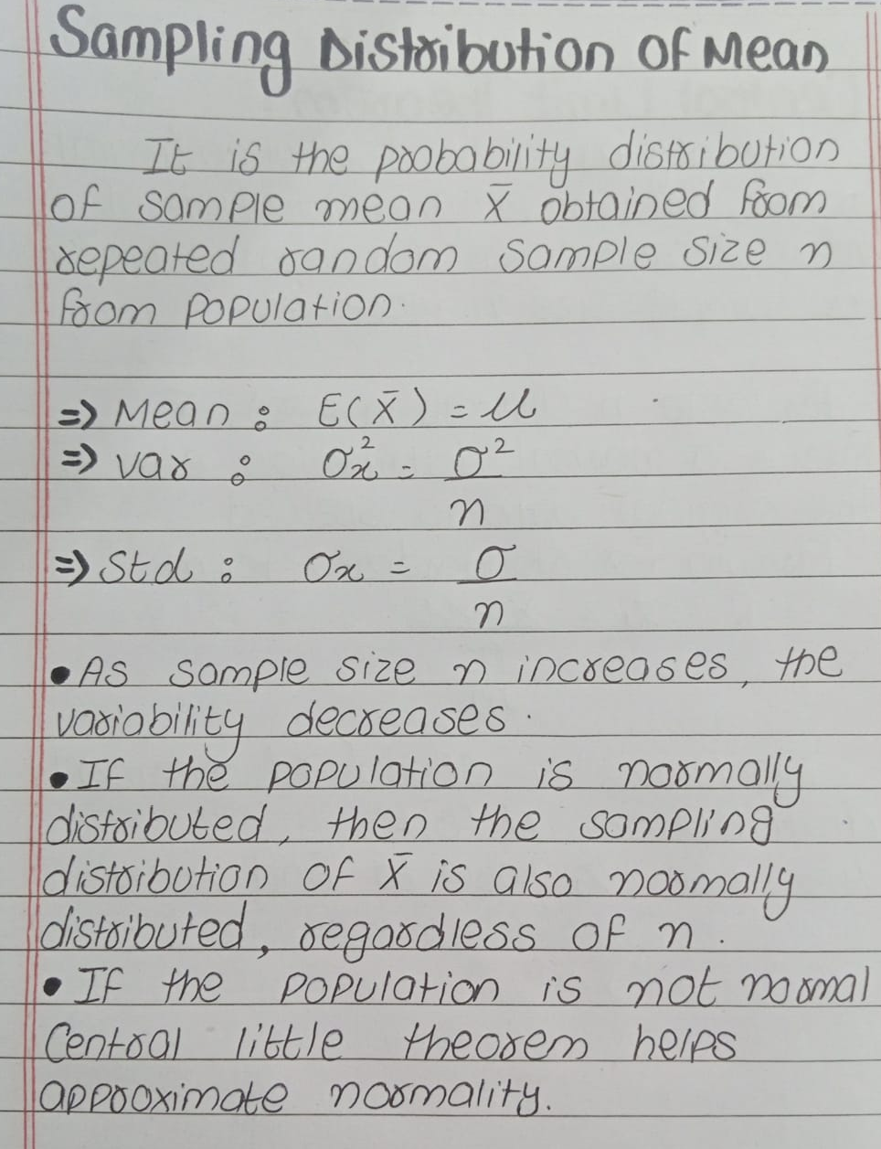

—----------------------------------------------------------------------------------------------------------------------------

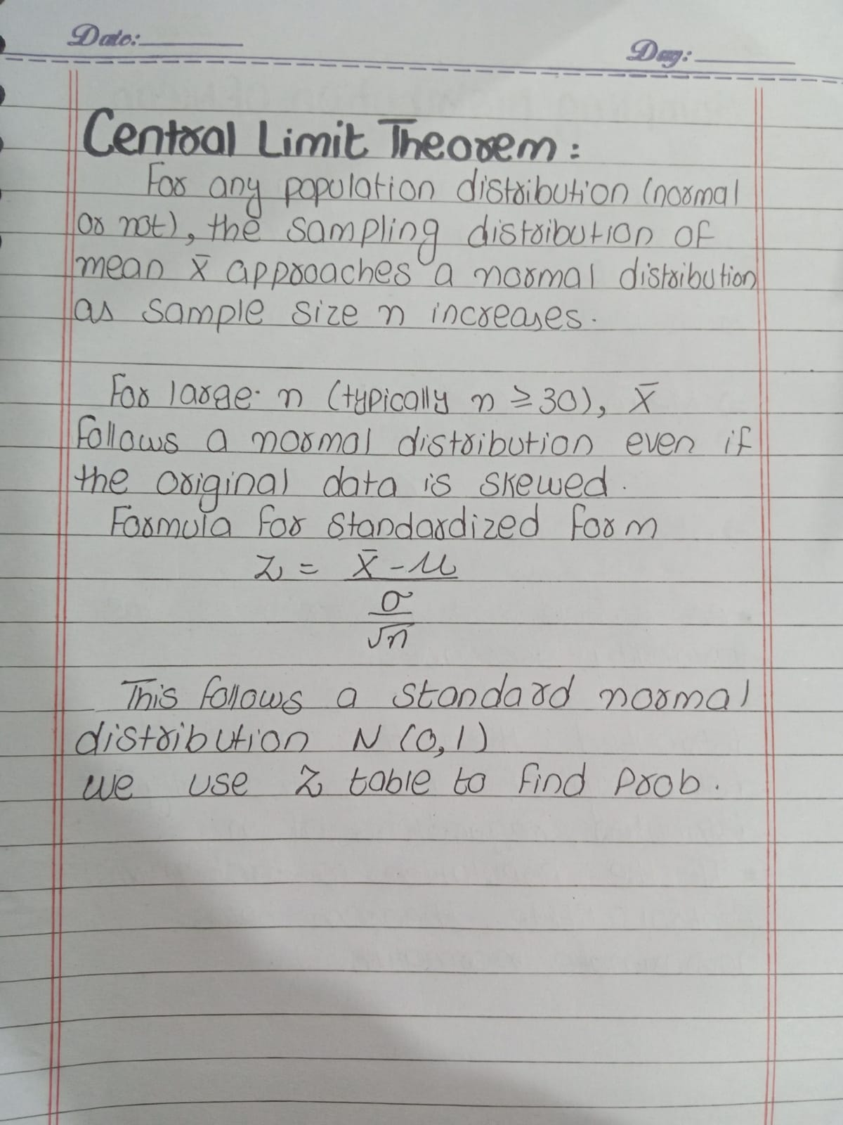

—----------------------------------------------------------------------------------------------------------------------------

Question 1: Understanding the Standard Error
A population has a mean μ=500 and standard deviation σ=80 If random samples of size n=25 are drawn, what is the standard error of the mean?
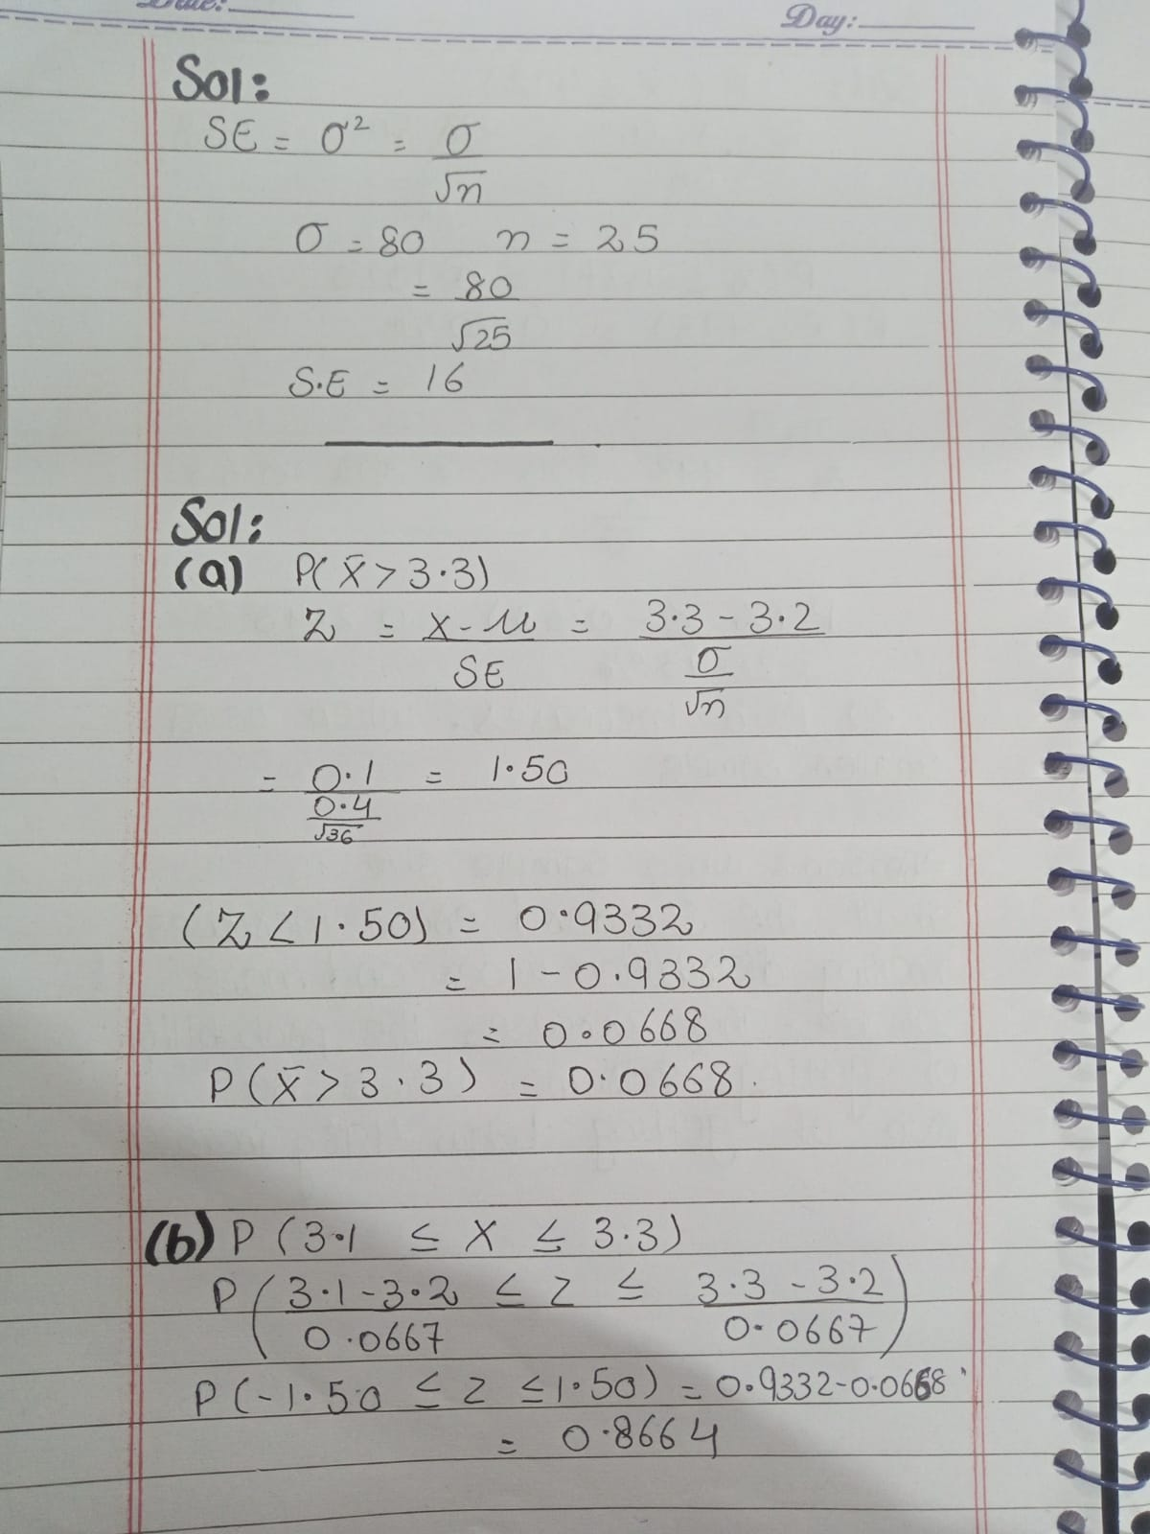
—----------------------------------------------------------------------------------------------------------------------------

Question 2: Applying the Central Limit Theorem
A university claims that the average GPA of its students is 3.2 with a standard deviation of 0.4. Suppose you take a random sample of 36 students:
(a) What is the probability that the sample mean GPA is greater than 3.3?
(b) What is the probability that the sample mean GPA is between 3.1 and 3.3?
—----------------------------------------------------------------------------------------------------------------------------

Question 3: Interpreting the Sampling Distribution
Suppose a machine fills cereal boxes with an average weight of 500g and a standard deviation of 10g. A quality inspector takes 40 boxes as a sample.
(a) What is the probability that the average weight of these boxes is less than 498g?
(b) If another inspector takes only 10 boxes as a sample, will the probability of getting an average below 498g increase or decrease? Why?

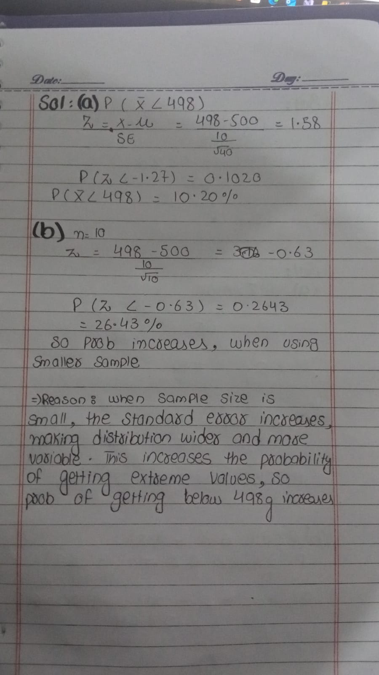

—----------------------------------------------------------------------------------------------------------------------------

Example 1: Light Bulb Lifespan A type of light bulb has a population mean lifespan of 800 hours with a standard deviation of 40 hours. A random sample of 16 light bulbs is selected. What is the probability that the average lifespan of the selected bulbs is less than 775 hours?
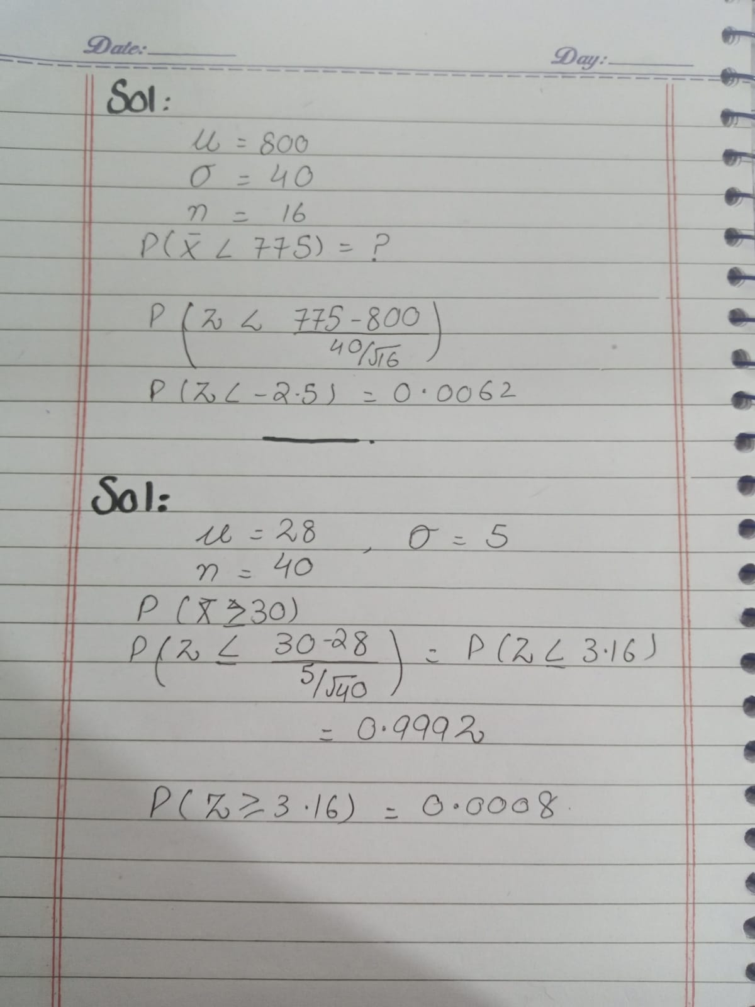

—----------------------------------------------------------------------------------------------------------------------------

Example 3: Shuttle Bus Time
The travel time of a shuttle bus follows a normal distribution with a mean of 28 minutes and a standard deviation of 5 minutes. A sample of 40 trips is selected.

Question:
What is the probability that the mean travel time for the sample is greater than 30 minutes?

—----------------------------------------------------------------------------------------------------------------------------

Practice question
Suppose that orders at a restaurant are IID random variables with mean = 8 and standard deviation = 2. Answer the following:

a)Estimate the probability that the first 100 customers spend a total of between 780 and 820



